SR UNIVERSITY

AI ASSIST CODING

*Lab:7 Environment Setup – GitHub Copilot and VS Code Integration*

ROLL NO:2503A51L10

NAME:K.Praneeth

BATCH:19

**TASK#1:**

**Prompt used:**

Introduce a buggy Python function that calculates the factorial of a number using recursion. Use Copilot or Cursor AI to detect and fix the logical or syntax errors.

**Code Generated:**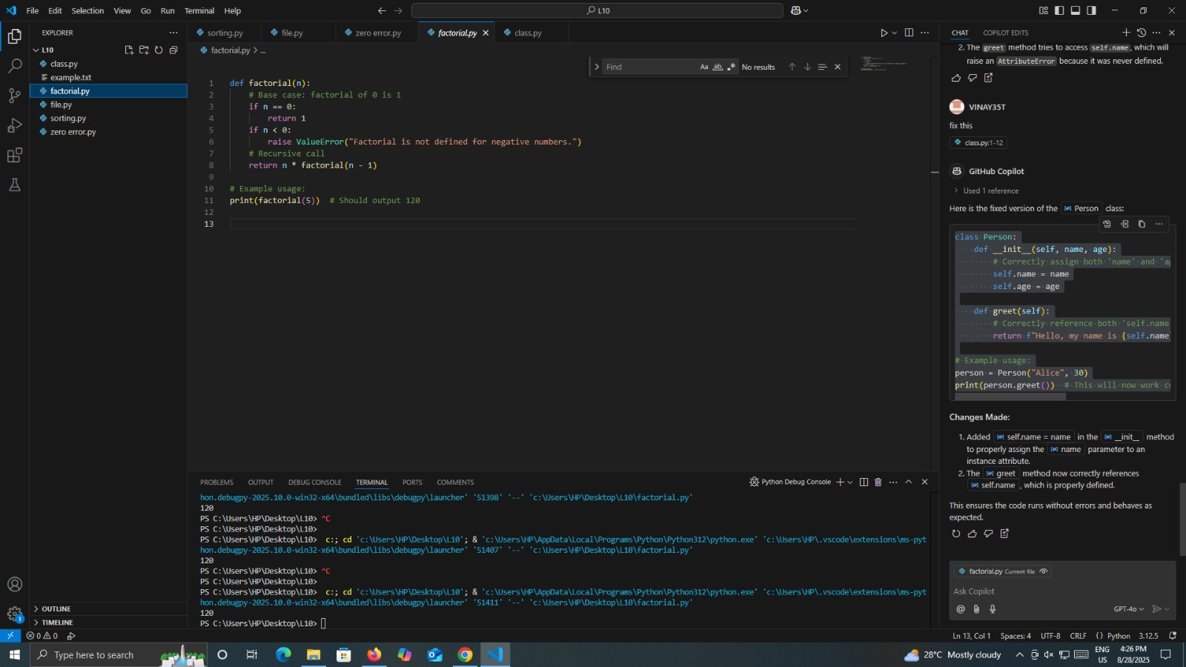

**Output After executing Code:**



**Observations:**

* in the task has questions to fix the bugs in the code of factorial given by the GitHub copilot i founded the bugs in that
* after fixing the bug the input is number is given 5 by using the factorial condition the output is 120

**TASK#2:**

**Prompt used:**

Provide a list sorting function that fails due to a type error (e.g., sorting list with mixed integers and strings). Prompt AI to detect the issue and fix the code for consistent sorting.

**Code generated:** 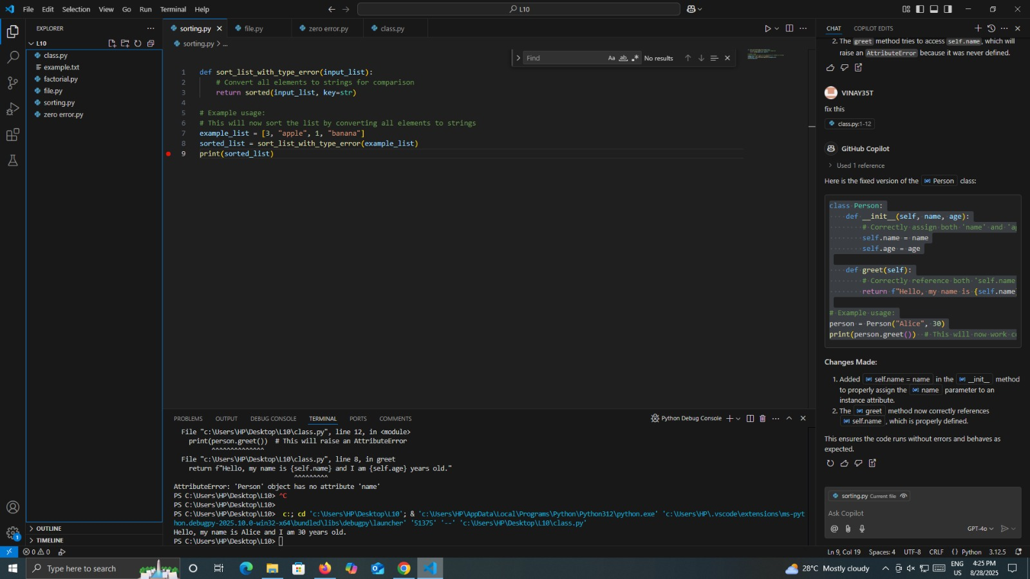

**Output after executing Code:**



**Observations:**

* By the following the sorting code generated by the git hub copilot has some errors the code is not executing correctly but after finding the errors and fixing it the sorting is properly excuted in the vscode

**TASK#3:**

**Prompt used:**

Write a Python snippet for file handling that opens a file but forgets to close it. Ask Copilot or Cursor AI to improve it using the best practice (e.g., with open() block).

**Code generated:**

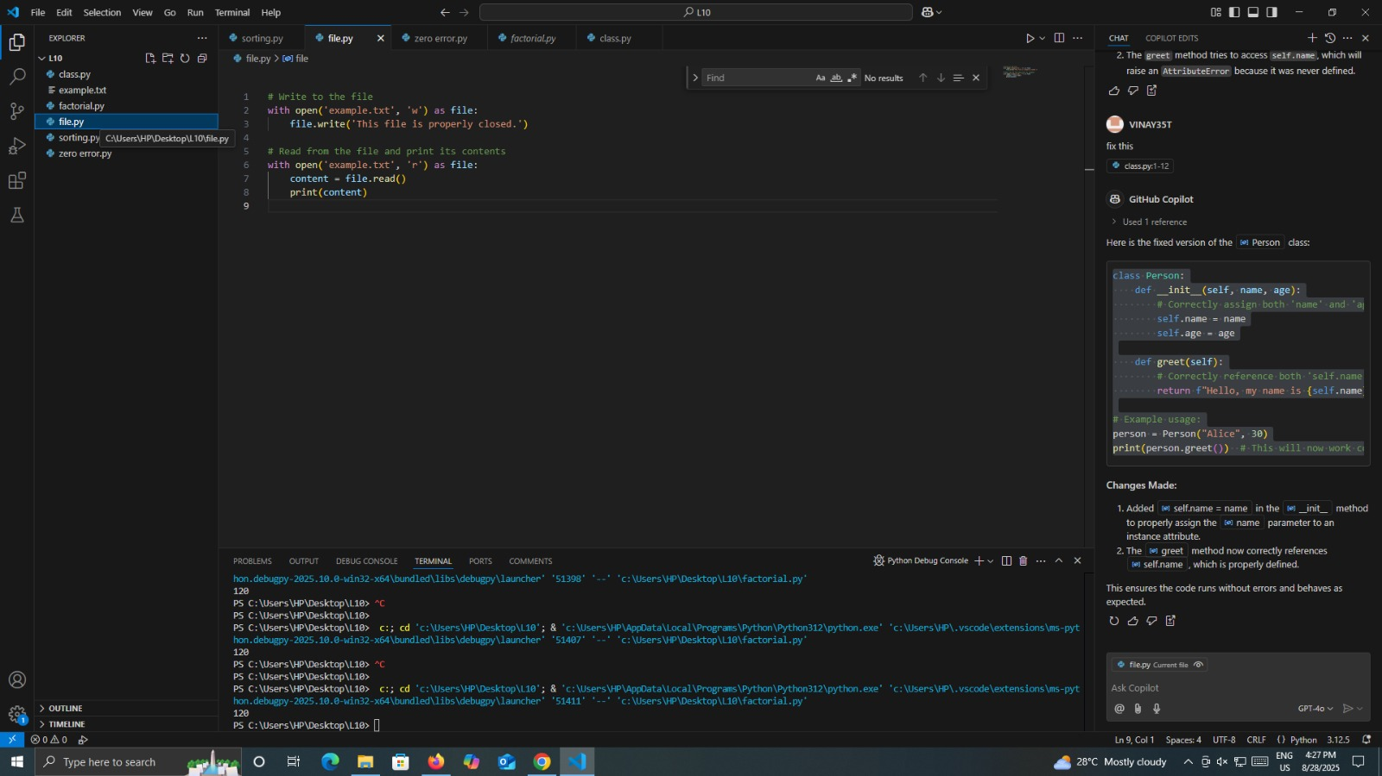

**Output after executing Code:**

**Observations:**

* Using the above code can't able to open the file which is provided by the GITHUB Copilot but after fixing it
* The files are able to open and there is a change of chance for editing it like name of the file and some content in it

**TASK#4:**

**Prompt used:**

Provide a piece of code with a ZeroDivisionError inside a loop. Ask AI to add error handling using try-except and continue execution safely.

**Code generated:**

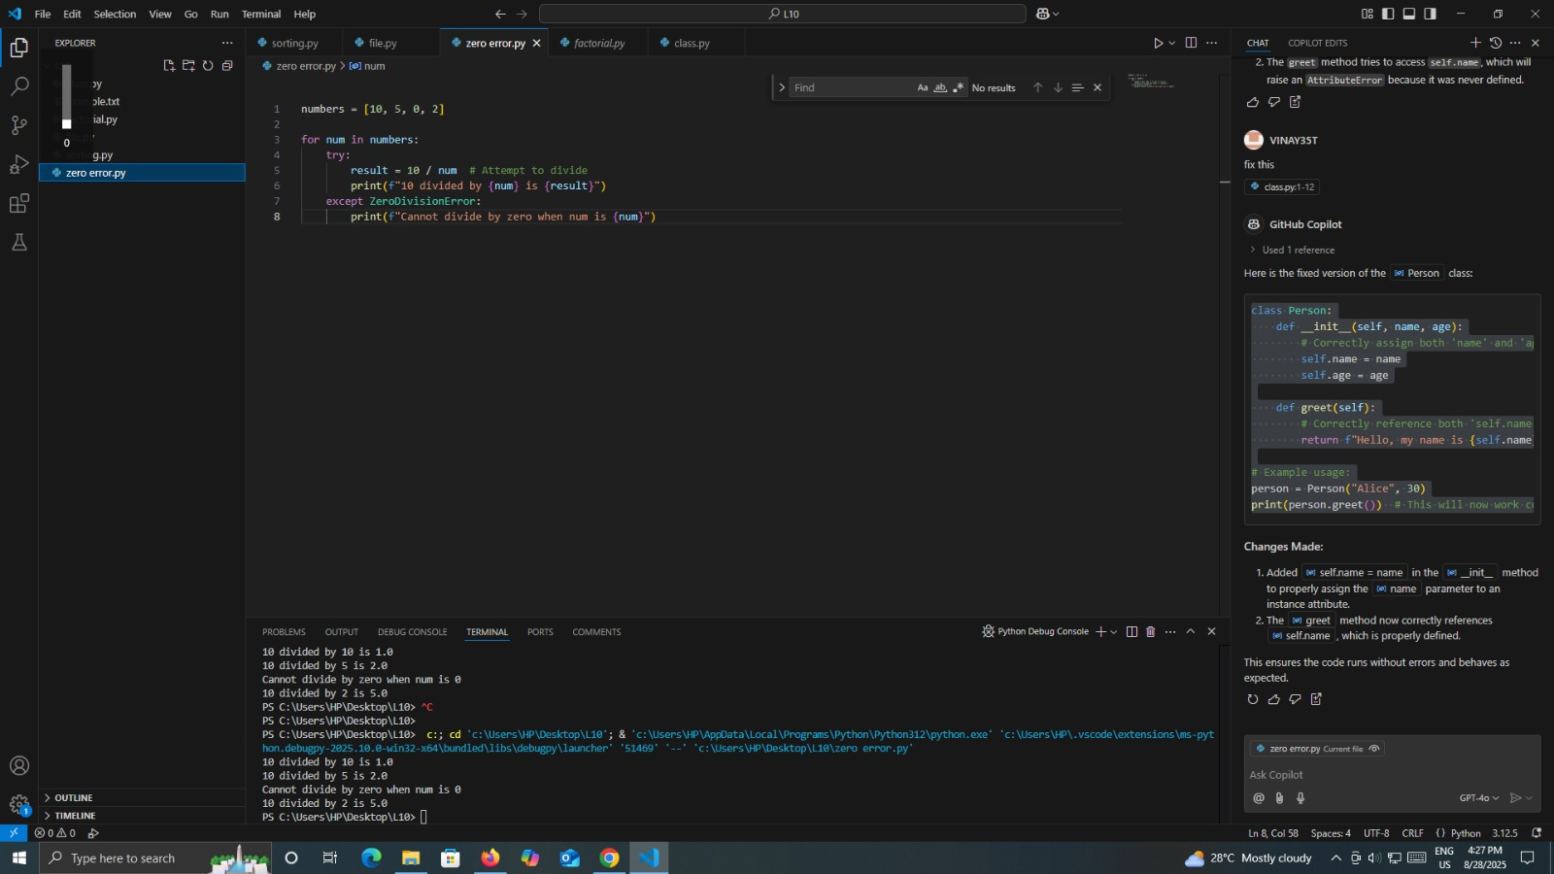

**Output after executing Code:**



**Observations:**

* in this above there are the error as knows as the exception occurs at the running time while we trying to do the division by the zero
* by using the AI and improve the error handing over the program the error occuring is decreased

**TASK#5:**

**Prompt used:**

Include a buggy class definition with incorrect __init__ parameters or attribute references. Ask AI to analyze and correct the constructor and attribute usage.

**Code generated:**

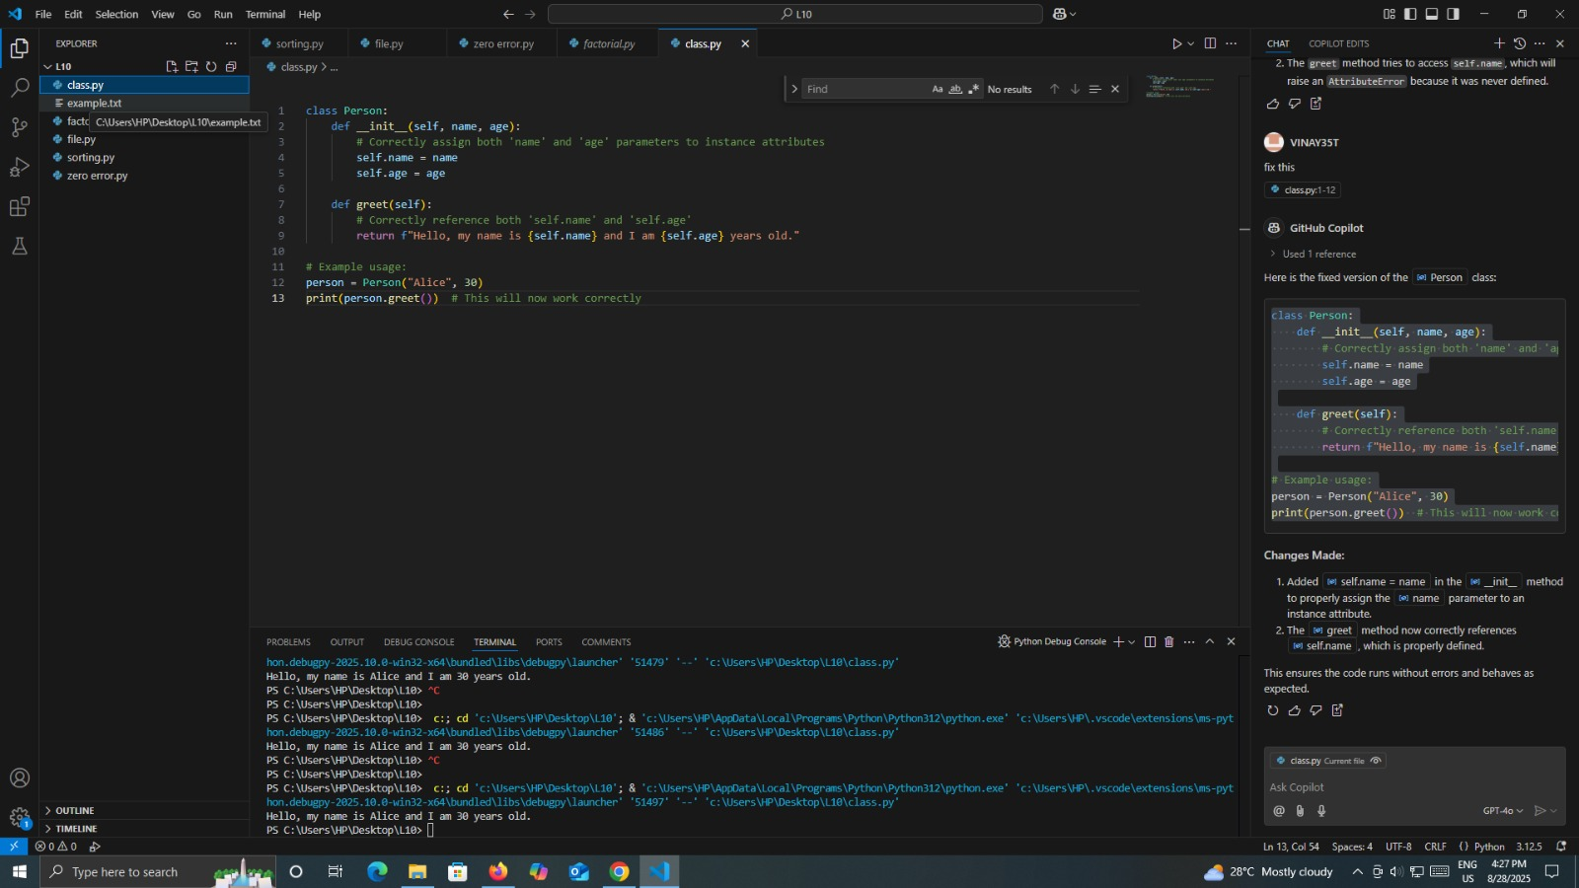

**Output after executing Code:**

**Observations**:

* The code has written manually by providing some errors like the class defination incorrectly and some the parameters doing the syntax errors and some mistakes
* we use the AI to analyse the code and detect the errors from the code eto fix it